Mb.No:-09932342784
NETAJI SUBHAS ASHRAM MAHAVIDYALAYA
(Affiliated to S.K.B University)
P.O: SUISA, DIST –PURULIA, PIN .723212
E-mail:-nsamtic@gmail.com. Webpage: - www.nsamsuisa.org.in
From:-Teacher-in-charge & secretary Date:-18.11.2019
Ref:-

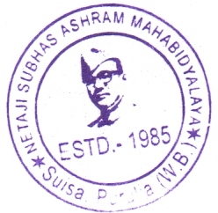

Examination Notification for Online Form Fill Up of UG
Semester–V (CBCS) 2019.

This is hereby informed to all students of B.A. Semester-V (CBCS) that their ON-LINE Form fill-up for final Examination 2019 will be conducted by the college office as per following schedule:-
For B.A.V Semester Honours & Program 18.11.2019 to 22.11.2019 – Without Late Fees.
For B.A. V Semester Honours & Program 25.11.2019, - With Late Fees.
N.B Form Fill-up will be conducted through ON-LINE Process and Fees will be received by the college CASH SECTION.
After this fixed schedule no students can fill-up their forms for B.A 5th Semester Examination 2019.
The arrangement of seats of B.A. 5th Semester Honours & Program Examination 2019 has been made by A.M. College, Jhalda.
(Kinkar Das)
Teacher–in–charge
Netaji Subhas Ashram Mahavidyalaya
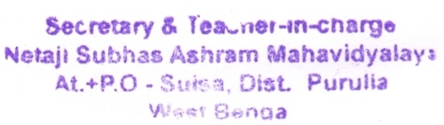
Form Fill-up Fee for 5th Semester :-
- Hons. (Bengali, History & English) Rs.- 600/-
- Hons. Geography Rs.-675/-
- Program Course Rs.- 500/-
- Late Fees Rs.- 100/-

